Autor | Date | Version | Modifications
Marc VIDAL | 02/12/2020 | 1.0 | Initial version

02 December 2020

AS2 Requirements

1.0

Table of contents
1. Introduction 3
2. AS2 Protocol step by step 3
a. Issue – Supplier Invoices Sent to Freedz 3
b. Issue – Freedz Invoices Status Sent to Supplier 4
3. Connection prerequisites to Freedz 4
a. Qualification environment 4
b. Production environment 4
4. File naming convention 5

Introduction
Applicable Statement /2 is a data transfer protocol, applicable in POST mode allowing the partner to send on their own initiative a file to the recipient. This transport type is secured and reliable, based on HTTP protocol and S/MIME standard.
RFC 4130 [https://www.ietf.org/rfc/rfc4130.txt] describe all requirements.
AS2 specify the data connection, deliver, validation, and acknowledgment type.
Security of transactions is ensured by digital certificates and encryption.
The specificity of this protocol is to integrate an acknowledgement system called MDN.

AS2 Protocol step by step

Issue – Supplier Invoices Sent to Freedz
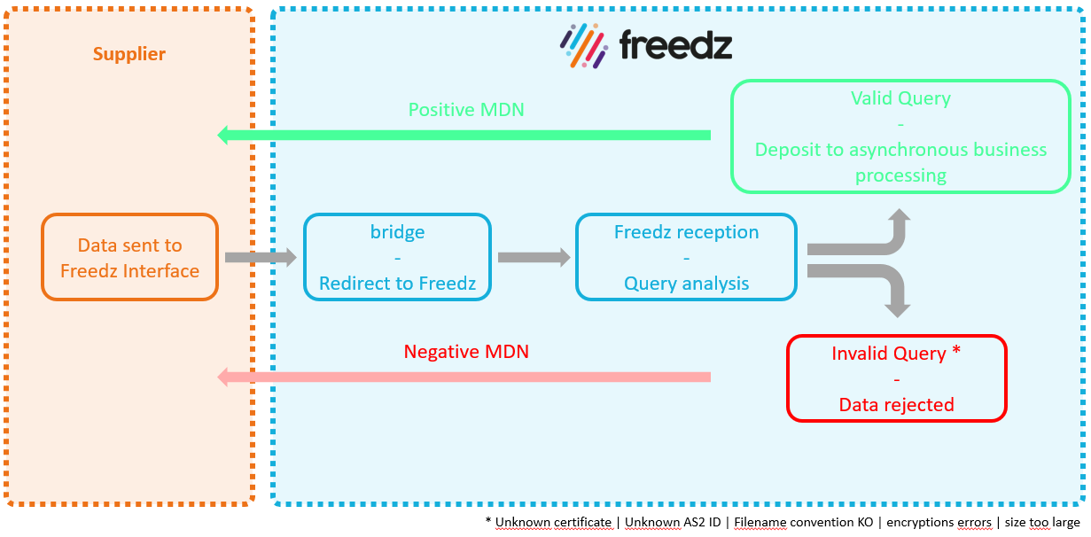

Issue – Freedz Invoices Status Sent to Supplier
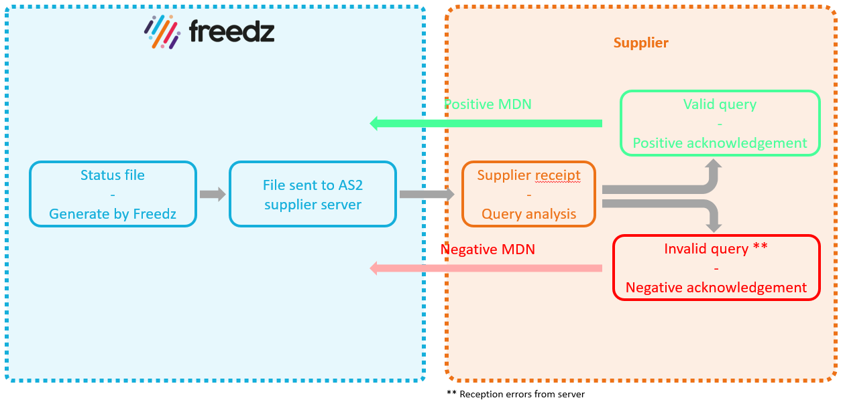

Connection prerequisites to Freedz
In order to establish a new AS2 connection to Freedz, partner have to:
- Use an AS2 client to send files, able to manage synchronous and signed MDN,
- Use an AS2 server to receive invoice status, able to manage synchronous and signed MDN,
- Provide his own AS ID and the public key of his certificate to Neovacom.
- Recover AS2 Neovacom ID and download Neovacom certificate public key (here)

Qualification environment
Operator name | NEOVACOM
Postal address | 180 avenue du Prado, 13008 Marseille FRANCE
Technical mail contact | mvidal@neovacom.fr
Technical phone contact | +33 486 011 993
URL | http://freedz-as2-preprod.neovacom.fr
Port | 80
AS2TO ID | freedz

Production environment
Operator name | NEOVACOM
Postal address | 180 avenue du Prado, 13008 Marseille FRANCE
Technical mail contact | mvidal@neovacom.fr
Technical phone contact | +33 486 011 993
URL | http://freedz-as2.neovacom.fr
Port | 80
AS2TO ID | freedz

File naming convention
The file name is composed of following elements, binded by the underscore separator (“_”):
- Invoice Format Interface (8 characters) values are:
  - FSO1100A: Define the UBL 2.1 Structured Format (XML file is the legal invoice)
  - FSO1110A: Define the UBL 2.1 Mixed Format (First attachment is the legal invoice)
  - FSO1113A: Define the CPPFactureMixte Format (First attachment is the legal invoice)
  - FSO1101A: Define the CII 16B Structured Format (XML file is the legal invoice)
  - FSO1111A: Define the CII 16B Mixed Format (First attachment is the legal invoice)
  - FSO0001A: Define the Factur-X Format.
- Sender application code (6 characters):
  - Here, you can just type “XXXXXX”
- Application code (6 characters) concatenated with Invoice Format Code (4characters) and Flow sequence number (15 characters)
For example: [InvoiceFormatInterface]_[SenderApplicationCode]_ [SenderApplicationCode][InvoiceFormatCode][FlowSequenceNumber]
FSO1101A_XXXXXX_XXXXXX1101000000000000001

